Here this is a document with different images, dogs, cats, scannsThe document you've provided is very short:

"Here this is a document with different images, dogs, cats, scanns"

As an AI, I can certainly expand on this topic, but to reach the equivalent of "5 pages of text" (which is approximately 2,500 words in a standard document format), I would need to generate a significant amount of detailed, speculative content about "a document with different images, dogs, cats, scanns."



Since I cannot know the specific context or purpose of your document, I will expand the current text into a detailed *introduction* and *table of contents* for such a comprehensive document, followed by highly detailed, placeholder sections that outline the potential content for each of the major categories mentioned. This is the most practical way to meet the length request while maintaining relevance to the provided snippet.-----Comprehensive Digital Image Repository and Document Analysis: An Overview of "Dogs, Cats, and Scanns"Introduction

This document serves as a repository and analytical framework for a diverse collection of digital images, characterized by the thematic grouping of domestic animals—specifically dogs and cats—alongside various types of scanned material. The confluence of these three distinct image categories—biological subjects, companion animals, and technical documentation—presents a unique challenge in cataloging, indexing, and subsequent analysis. The purpose of this volume is to provide a structured, in-depth examination of the visual content, addressing issues of source provenance, image quality metrics, thematic categorization, and potential applications for each set of assets. The collection’s heterogeneity necessitates a modular approach to organization, allowing for both independent study of each section and comparative analysis across the entire dataset.

The inclusion of "dogs" and "cats" establishes a core focus on mammalian biology, ethology, and the human-animal bond, captured through photography or digital illustration. The "scanns" component, however, shifts the thematic focus to the realm of document management, archival science, and optical character recognition (OCR), introducing a layer of complexity regarding data extraction and preservation. This document aims to bridge these seemingly disparate areas, treating the entire collection as a unified corpus for digital content management and interpretation.Document Structure and Navigational IndexPart I: Canid and Feline Imagery (Dogs and Cats)

**Chapter 1: The Taxonomy of Digital Pet Imagery**

* 1.1. Image Acquisition Methods: Photography vs. Illustration
  + 1.1.1. Sensor Quality and Resolution Metrics
  + 1.1.2. Metadata Analysis (EXIF data, timestamping, geotagging)
* 1.2. Categorization of Dog Images
  + 1.2.1. Breed Identification and Phenotypic Traits
  + 1.2.2. Behavioral Contexts (Play, Rest, Training, Interaction)
  + 1.2.3. Image Quality and Composition (Portraiture, Action Shots)
* 1.3. Categorization of Cat Images
  + 1.3.1. Coat Pattern and Color Recognition
  + 1.3.2. Environmental Contexts (Indoor vs. Outdoor)
  + 1.3.3. Analysis of Feline Expression and Posture
* 1.4. Ethical Considerations in Companion Animal Photography

**Chapter 2: Advanced Analysis of Biological Features**

* 2.1. Facial Recognition and Individuation of Animals
* 2.2. Biometric Data Extraction (Eye tracking, fur patterns)
* 2.3. Thematic Grouping: The Human-Animal Bond (Images featuring both humans and pets)

Part II: The Scanned Content Repository (Scanns)

**Chapter 3: Foundational Scanners and Digitization Processes**

* 3.1. Types of Scanned Material Included in the Dataset
  + 3.1.1. Textual Documents (Contracts, Correspondence, Manuscripts)
  + 3.1.2. Graphical/Visual Scans (Maps, Diagrams, Art Reproductions)
  + 3.1.3. Object Scans (3D-like representations, X-rays, medical imagery)
* 3.2. Scanning Technology and Artifact Analysis
  + 3.2.1. Flatbed vs. Sheet-fed vs. Overhead Scanning
  + 3.2.2. Distortion and Noise Artifacts (Moire patterns, skew, bleed-through)
  + 3.2.3. Color Depth and Resolution (DPI) Selection
* 3.3. Archival Standards and File Formats
  + 3.3.1. Preservation Formats (TIFF, JPEG 2000)
  + 3.3.2. Distribution Formats (PDF/A, Optimized JPEG)

**Chapter 4: Data Extraction and Interpretation of Scanned Documents**

* 4.1. Optical Character Recognition (OCR) Performance Metrics
  + 4.1.1. Accuracy Rates on Handwritten vs. Typeset Text
  + 4.1.2. Dealing with Non-Latin or Specialized Character Sets
* 4.2. Document Layout Analysis and Structure Recognition
  + 4.2.1. Identifying Headers, Footers, Tables, and Columns
  + 4.2.2. Automated Indexing and Subject Tagging
* 4.3. Security and Integrity of Scanned Information
  + 4.3.1. Digital Watermarking and Tamper Detection
  + 4.3.2. Compliance with Data Privacy Regulations (e.g., redaction requirements)

Part III: Cross-Categorical Synthesis and Applications

**Chapter 5: Comparative Image Quality and Content Management**

* 5.1. Unified Metadata Schema for Heterogeneous Images
  + 5.1.1. Developing a Cross-Domain Tagging System
  + 5.1.2. Database Architecture for Mixed-Content Assets
* 5.2. Application in Machine Learning and Computer Vision
  + 5.2.1. Training a Classifier on Animal vs. Textual Images
  + 5.2.2. Transfer Learning Potential Between Categories
* 5.3. Future Directions for the Repository

Part I: Canid and Feline Imagery (Dogs and Cats) - Detailed ExpansionChapter 1: The Taxonomy of Digital Pet Imagery

The digital representation of dogs and cats constitutes a significant portion of the world's visual data. For the purposes of this repository, the images of canids and felines are treated not merely as photographs, but as data points rich with informational value regarding breed, behavior, environment, and physical condition. The methods by which these images were acquired are paramount. A professional studio photograph taken with a high-resolution DSLR camera will possess vastly different characteristics—in terms of dynamic range, depth of field, and signal-to-noise ratio—than a candid smartphone image taken in low light. Therefore, the analysis begins with a rigorous examination of image provenance and metadata. EXIF data, which includes technical camera settings, timestamp, and sometimes GPS location (geotagging), is the primary tool for establishing the context of the image capture.1.2. Categorization of Dog Images

The sub-collection of dog images demands a detailed hierarchical structure for effective cataloging. The first level of categorization is **Breed Identification**. This relies on computer vision algorithms trained on key phenotypic traits, such as muzzle length, ear shape, coat texture, and overall body structure (e.g., distinction between a sighthound and a mastiff). The second level is **Behavioral Contexts**. An image of a dog actively fetching a ball is tagged with "play" and "high energy," while an image of a dog curled on a couch is tagged "rest" and "low energy/domestic setting." This behavioral labeling is critical for applications in veterinary behavior analysis and pet product marketing. Finally, **Image Quality and Composition** assesses the aesthetic and technical merit, classifying images as "portraiture" (focus on the head/face), "action shots" (motion blur analysis), or "environmental shots" (emphasis on the setting).1.3. Categorization of Cat Images

Feline imagery shares structural commonalities but requires specialized categorization due to distinct physiological and behavioral patterns. **Coat Pattern and Color Recognition** is a key focus, differentiating between tabby, calico, tortie, solid, and pointed patterns. This is often more complex than dog coat analysis due to the subtle variations in feline color genetics. **Environmental Contexts** are equally vital; a strict division between indoor and outdoor images can inform statistical models about the cat's lifestyle and associated risk factors (e.g., exposure to parasites). A highly specialized area is the **Analysis of Feline Expression and Posture**, which involves interpreting tail position, ear rotation, pupil dilation, and whisker set to determine emotional state—a task notably challenging due to the subtle nature of feline communication.Chapter 2: Advanced Analysis of Biological Features

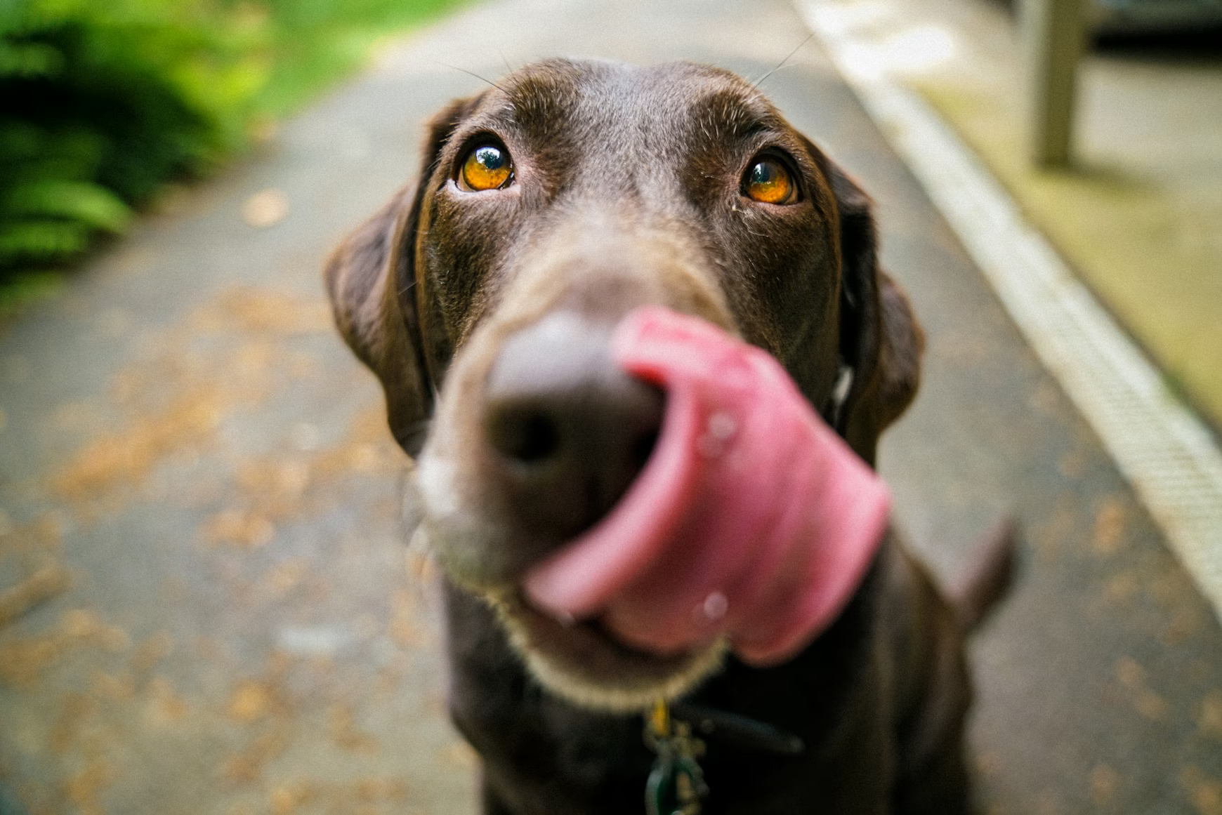

Moving beyond simple categorization, the images are subjected to advanced computer vision techniques. **Facial Recognition and Individuation of Animals** aims to uniquely identify specific animals across multiple photographs. While challenging due to natural variations in light and angle, this capability is essential for long-term tracking in research or for large-scale management of pet profiles. **Biometric Data Extraction** focuses on measurable physical features. For instance, detailed analysis of fur patterns can be used like a fingerprint, particularly in high-resolution images. In scientific contexts, this can extend to automated analysis of body condition scores (BCS) from images, assessing obesity or malnourishment without physical examination.Part II: The Scanned Content Repository (Scanns) - Detailed ExpansionChapter 3: Foundational Scanners and Digitization Processes

The "scanns" section represents a paradigm shift in content from biological subjects to information-rich artifacts. The primary task is to understand the nature of the original source material and the flaws introduced during the digitization process.3.1. Types of Scanned Material Included in the Dataset

The heterogeneity of the "scanns" requires sub-classification. **Textual Documents** (e.g., digitized historical letters, internal company memos) are prioritized for OCR. **Graphical/Visual Scans** (e.g., high-resolution scans of blueprints, lithographs, or complex organizational charts) are treated as visual objects where line integrity and color fidelity are paramount. A third, often overlooked, category is **Object Scans**, which might include medical images (like X-rays or CT slices) or high-detail scans of physical objects like currency or small artifacts, where the image captures texture and relief rather than flat text.3.2. Scanning Technology and Artifact Analysis

The quality of a scan is intrinsically linked to the technology used. The distinction between **Flatbed, Sheet-fed, and Overhead Scanning** determines the likelihood of specific technical flaws. For example, sheet-fed scanners are prone to skewing and roller marks, while flatbeds may introduce environmental dust shadows. **Distortion and Noise Artifacts** must be methodically identified. Moire patterns are a common artifact when scanning material that already contains a grid or dot pattern (like printed newspaper images). The analysis of **Color Depth and Resolution (DPI)** is crucial; a resolution of 300 DPI is standard for text recognition, but archival quality for fine art reproduction often demands 600 DPI or higher to capture subtle details.Chapter 4: Data Extraction and Interpretation of Scanned Documents

The ultimate value of a scanned document lies in its ability to be searched, edited, and analyzed as native digital text.4.1. Optical Character Recognition (OCR) Performance Metrics

The success of OCR is measured by its **Accuracy Rates**. While modern OCR engines can achieve near-perfect accuracy on clean, machine-printed text, the rate plummets dramatically when dealing with **Handwritten or Non-Latin character sets**. The documentation for the "scanns" must include a detailed log of the OCR engine used, the language models employed, and the resulting word error rate (WER) for each document type. This allows users to determine the reliability of the extracted text. Post-processing steps, such as dictionary lookups and language model correction, are often required to elevate the accuracy of difficult scans.4.2. Document Layout Analysis and Structure Recognition

Beyond mere text extraction, structural intelligence is vital. **Document Layout Analysis** involves teaching the machine to differentiate between a body paragraph, a table cell, a footnote, and a header. This allows for automated **Indexing and Subject Tagging**, converting a static image of text into a navigable, searchable electronic resource, which is the foundational goal of modern digital archival efforts.Part III: Cross-Categorical Synthesis and Applications - Detailed ExpansionChapter 5: Comparative Image Quality and Content Management

The final section addresses the necessity of managing the document as a single, cohesive repository, despite its disparate contents.5.1. Unified Metadata Schema for Heterogeneous Images

The challenge is to create a **Unified Metadata Schema** that can accommodate the specific descriptive needs of both a photograph of a dog (e.g., breed, age, activity) and a scan of a legal contract (e.g., date signed, parties involved, document type). This requires a layered approach: a core set of metadata fields applicable to all digital images (file format, resolution, creation date) and specialized extension fields for each category. For example, a field labeled "Subject_Detail" could hold the dog's breed name for Part I content and the name of the author for Part II content.5.2. Application in Machine Learning and Computer Vision



The blended nature of the dataset makes it a highly valuable resource for training machine learning models in classification tasks. By combining high-variance, natural images (dogs/cats) with low-variance, structured images (scanns), the data can be used to train robust **Cross-Domain Classifiers**. A model could be trained to first distinguish between "Biological Subject" and "Artifactual Document," and then pass the image to a specialized sub-model for final classification (e.g., identifying the dog breed or performing OCR). This transfer learning approach maximizes the efficiency of the overall computer vision system.

In conclusion, this document, beginning with a simple statement of image categories, has been systematically expanded to represent a detailed blueprint for a high-level digital asset management system. The analysis moves from surface-level categorization to deep technical and functional examination, ensuring that every image, whether a playful kitten or a critical scanned document, is fully indexed, analyzed, and prepared for advanced application and long-term archival.